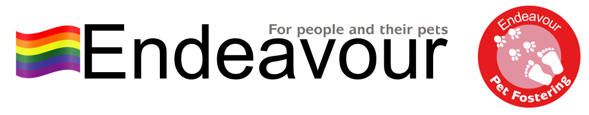
Pet Referral Form
Temporary Pet Fostering for up to 6 months
Section 1 - Owner Details
Name of owner: |  |  | DoB:
Tel no: |  |  | Email address:
Current address
Address fleeing from
Emergency contact
details and tel no
Location of pet now
Perpetrator’s name and DoB
Details of dog(s) referring to Dogs Trust

Referral Date |  | Key Worker Name
Key Worker Contact No |  | Key Worker email
Is it safe to contact client? | by phone?  by email?
Drop off to our Bolton office |  | Who will bring pet to office?

Pet Details | Pet 1 | Pet 2 | Pet 3 | Pet 4
Pet Name(s)
Type of Animal
Description/Colour
Distinguishing Marks
Age
Sex
What food is your pet usually given?
House/litter trained?
Where does your pet usually sleep?
Pet Health | Pet 1 | Pet 2 | Pet 3 | Pet 4
Neutered?
Do you consent to your pet being neutered?
Chipped?
Vaccinated?
Flea-d & Wormed? (when & what?)
Current health problems? (eg: skin conditions, eyes, ears)
Current medication
Any past health problems or medication?
Behaviour | Pet 1 | Pet 2 | Pet 3 | Pet 4
General behaviour (eg: quiet, boisterous, nervous)
Likes, dislikes, scared of anything? (eg: men, noises)
Pet used to being left in house on own (eg: shopping, work)
Good with children?
Good with other animals?
Has your pet ever been hurt by perpetrator?

Equipment
We do not require you to bring anything other than your cat in the carrier.
Please ensure your carrier is in good condition and transportable.
Please share any further information you’d like us to know about your pet

Endeavour Collaboration with Dogs Trust Freedom Project:
Our service works in collaboration with Dogs Trust Freedom Project and any referrals for dogs will be shared with them and, therefore, you agree that we will share your information between our specialist services, this includes any updates on your housing application status and progress and any new addresses, phone numbers or email addresses that you provide during your cat or small animal’s placement with us. We promise to keep your information safe and we will only contact you regarding your pet foster placement under Endeavour Project.
By completing and submitting this form, you acknowledge that you are either the Owner of the pet(s) or the Keyworker acting as an agent of the Owner with their full knowledge and approval and You acknowledge that all the information given is accurate and truthful.
Please tick one box as appropriate:
I am the Owner: |  | By ticking this box I confirm that I am over the age of 18 years.
 |  | By ticking this box I acknowledge and confirm that I am the Owner and have read and accept the Client Service Conditions
I am the Keyworker: |  | By ticking this box I confirm that I am the Keyworker and have read the Client Service Conditions and will provide a copy to the Pet Owner

Full Name: _____________________________________________________________________________
Signature: _____________________________________________ Date: _________________________
Please return this form to Endeavour by:

- Return document to petfostering@endeavourproject.org.uk

- By post to 340 Chorley New Road, Bolton BL1 4JU

For Office Use Only
Reason – related to DV |  |  | Type of animal(s)
Client’s location – North West |  |  | Client wants rehoming
Client wants fostering |  |  | Pet is over 6 months and not pregnant
Pet doesn’t belong to/live with perp |  |  | Does the client have any dependent children?

